**ASSIGNMENT 2**

NAME: **KVND SAI HARSHITH**

REGD NO: **20BCE7084**

CREATE IN MYSQL:

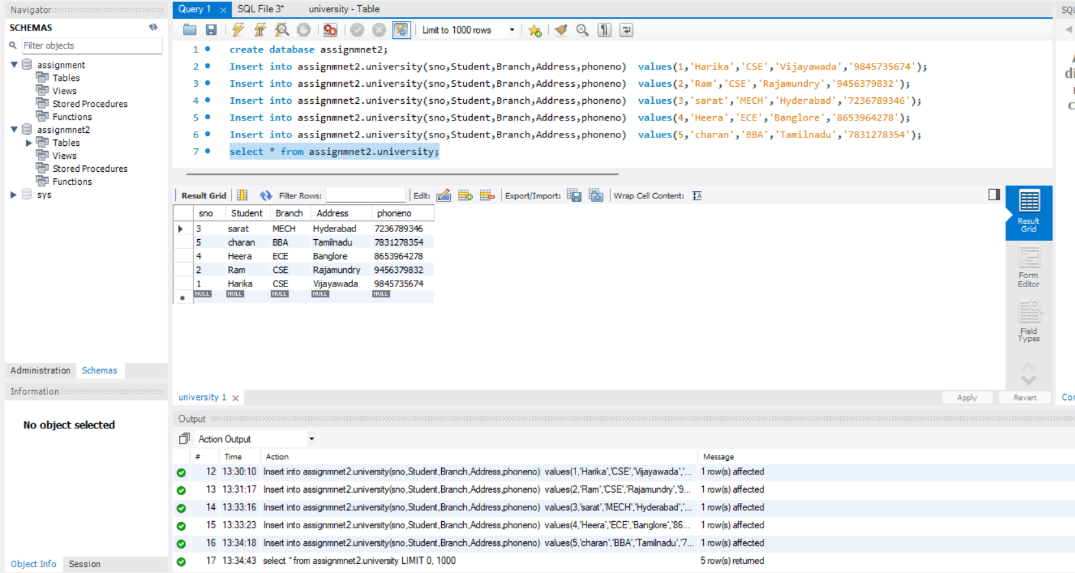

UPDATE COMMAND IN MYSQL:

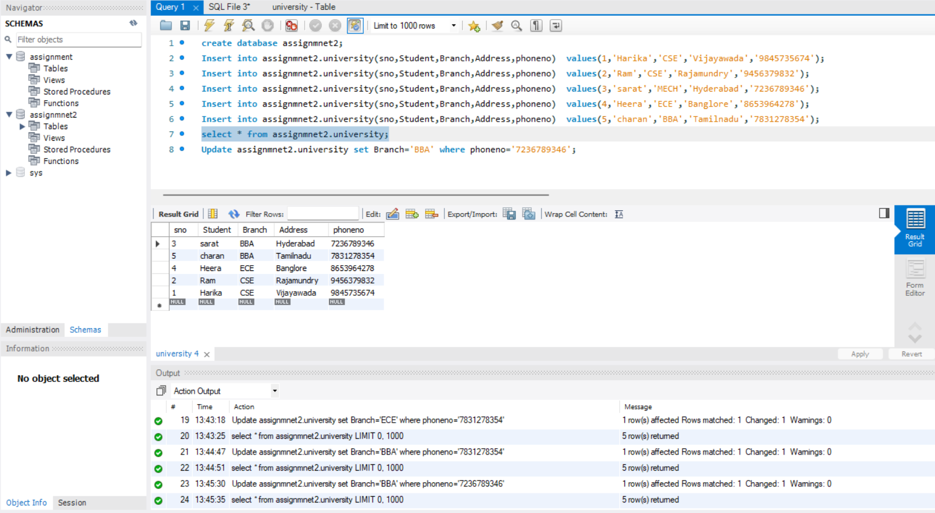

DELETE COMMAND IN MYSQL:

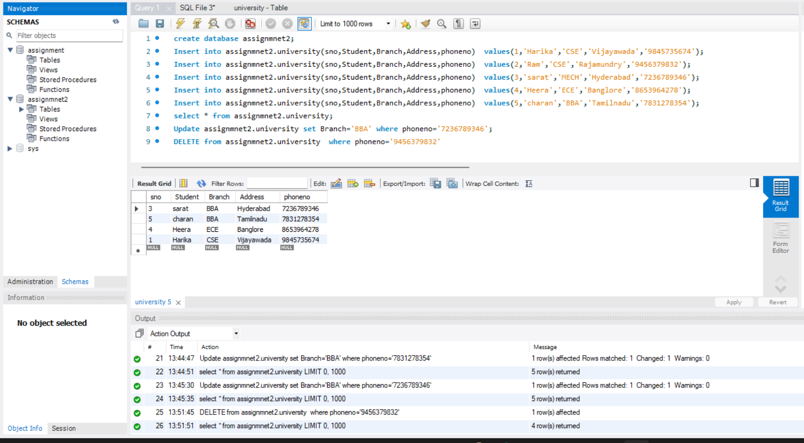

CREATING RELATIONAL TABLES IN MYSQL:

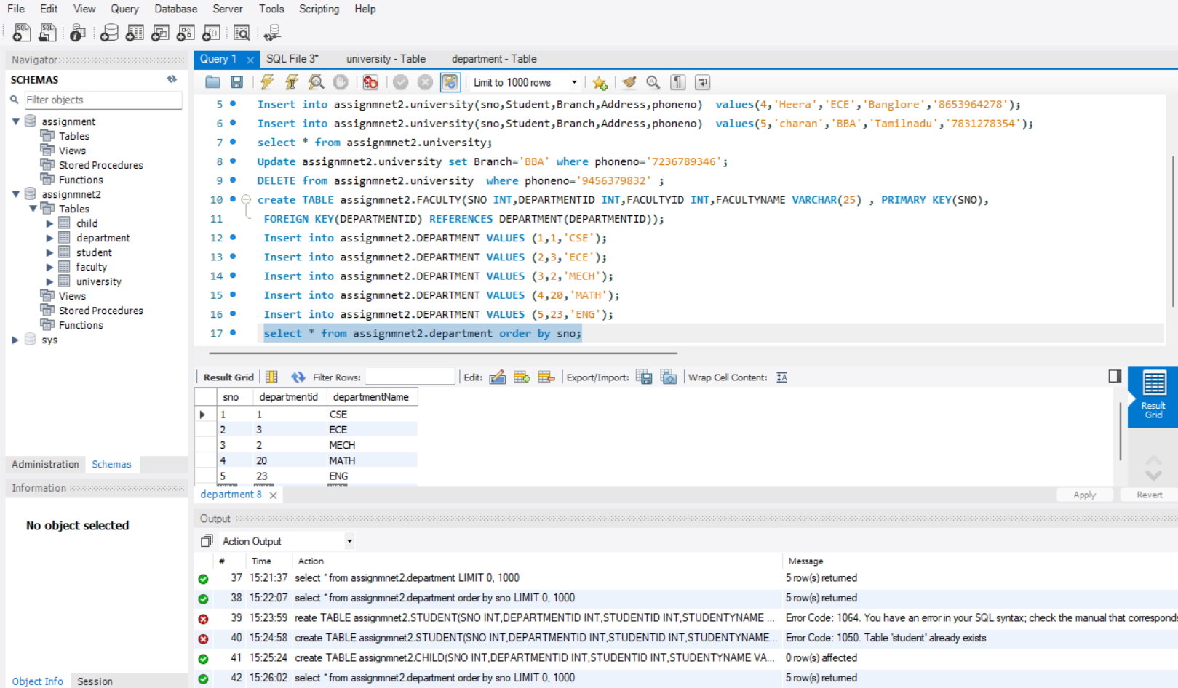

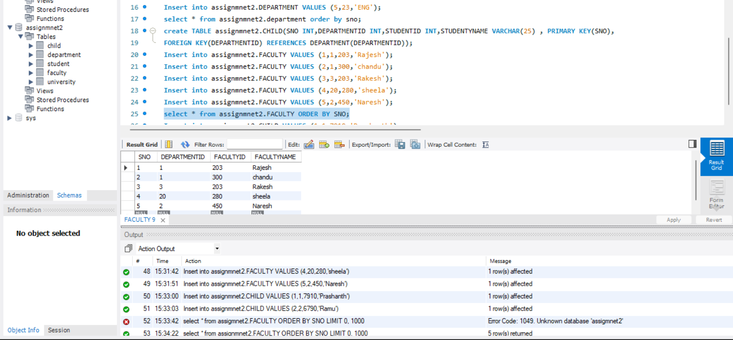

INNER JOIN:

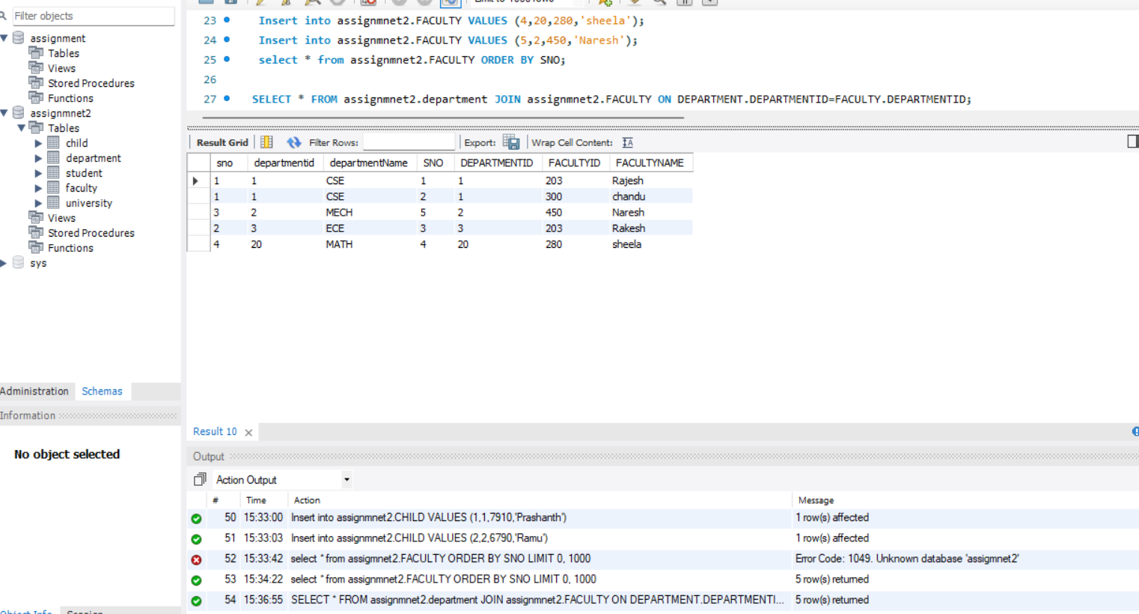

LEFT JOIN:

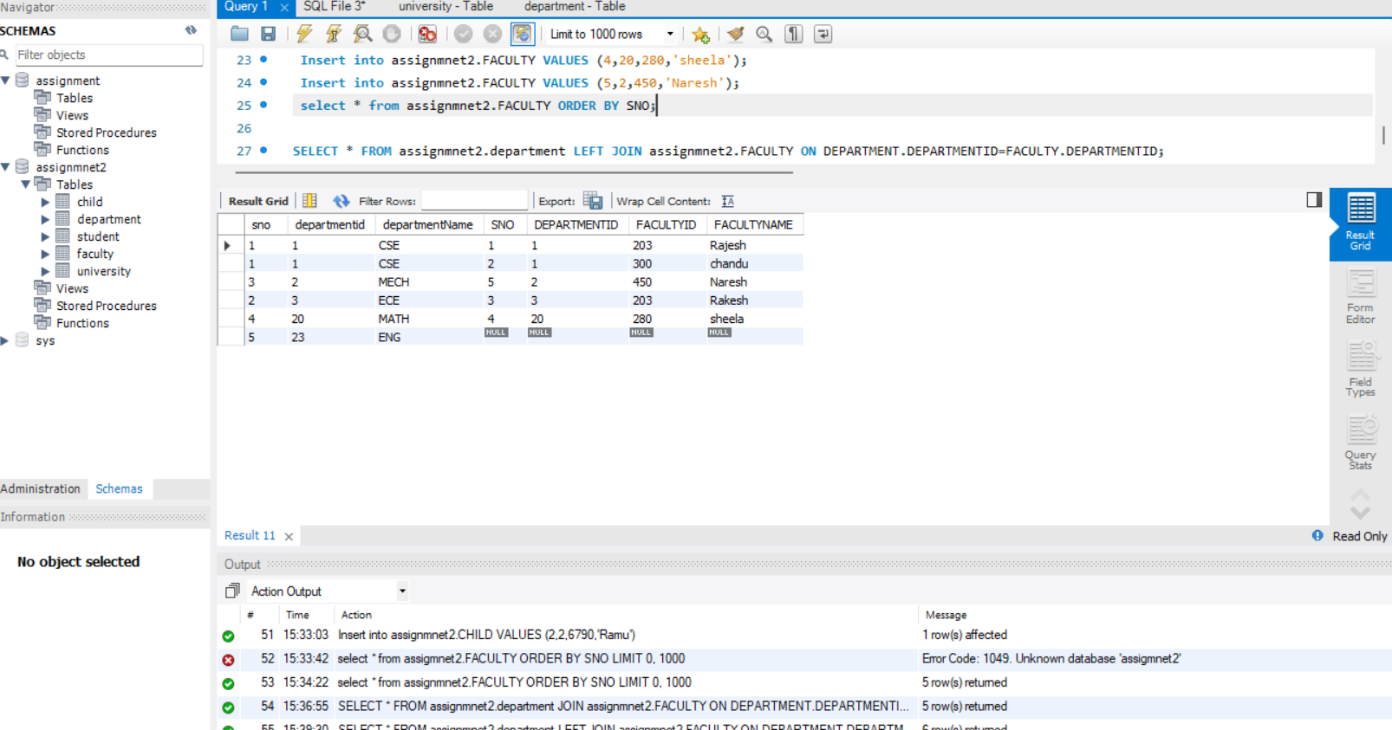

RIGHT JOIN:

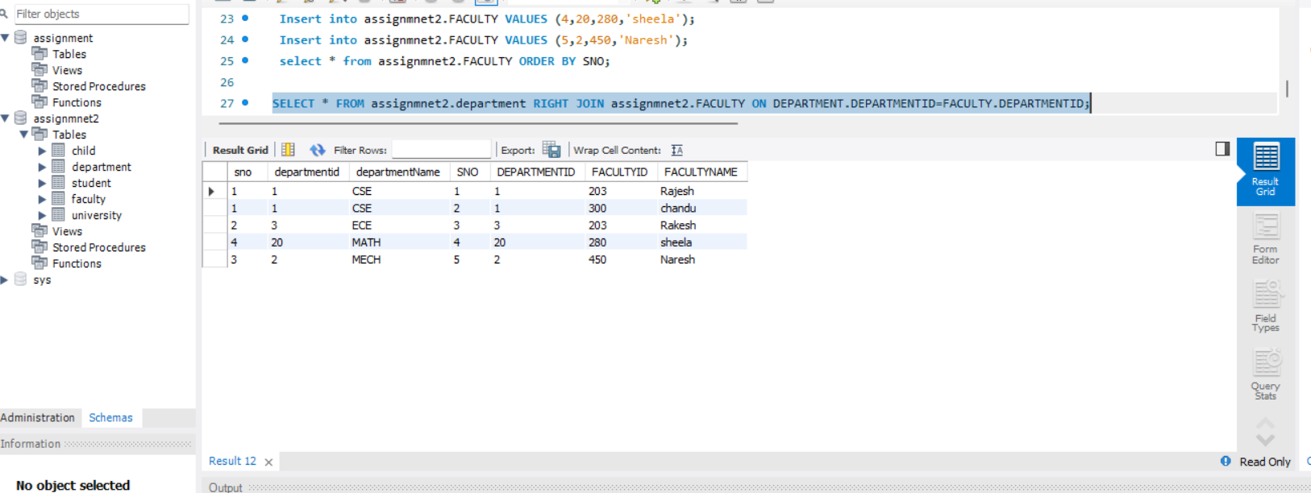

FULL JOIN:

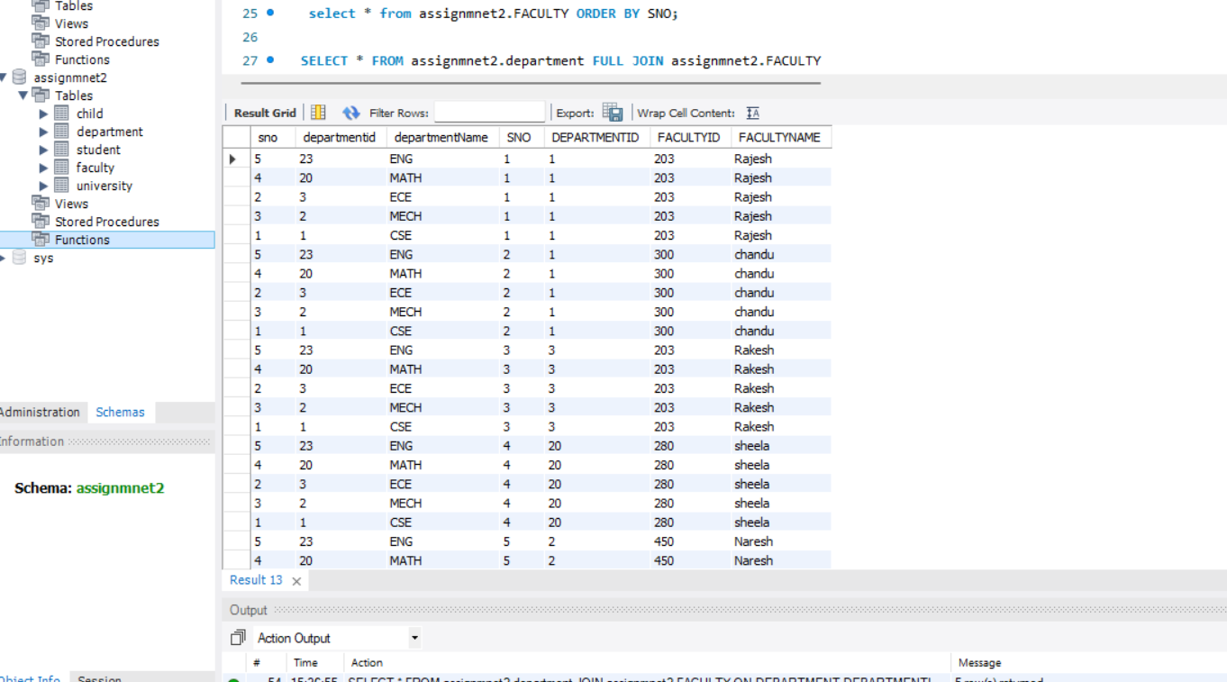

MONGODB:

Inserting documents using Mongoshell:

